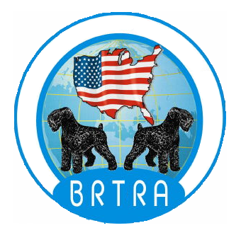
Black Russian Terrier Rescue Association
Surrender Contract
I, __________________________________________________, being the owner of
_________________________________________(name), a Black Russian Terrier ,
DOB or age: _____________________ Sex: (Male) (Female),
AKC Registration Number: _____________________
hereby relinquish all claims and ownership of said animal to the organization known as The Black Russian Terrier Rescue Association (BRTRA). I acknowledge that the final decision for placement of the animal belongs exclusively to the BRTRA.

I agree to give the Black Russian Terrier Rescue Association the dog's AKC registration papers, if any, and all available medical records as well as any medications used by the dog.
I __do/ ___ do not (check one) certify that this animal is not vicious and has never shown signs of aggression toward human beings or other animals. (Explain on back)
*** If I fail to disclose any previous aggressive behavior (such as attempts to bite, even if no contact was made), I agree to reimburse the Black Russian Terrier Rescue Association for all costs and liability it may incur because of the dog's subsequent aggressive behavior.
I am surrendering this dog to Black Russian Terrier Rescue Association with the understanding that the organization will attempt to find the animal a suitable home. The BRTRA and its officers will not be held responsible for the actions of the adoptive or foster families and/or the dog. If the BRTRA deems this dog to be unsuitable for adoption due to unacceptable temperament or other reasons, I understand that the BRTRA reserves the right to euthanize the dog.
The Black Russian Terrier Rescue Association does not require a surrender fee, but expenses will be incurred in caring for the dog prior to adoption, and help is needed for dogs with medical problems and for general costs of the organization. Donations, therefore, are absolutely encouraged. Suggested donation: $100, spayed or neutered, $200 unaltered.
Dog Surrendered to (Print Name): ______________________________
Signed: ___________________________________________________
Print Name: ________________________________________________
Address: __________________________________________________
Phone: ____________________________Date: ___________________
Witnessed on behalf of the BRTRA: _____________________________
Date: _____________________

